Liège Summer Dance Intensive
Boarding school from 4 to 11 August 2024 at Yust Liège Guillemins
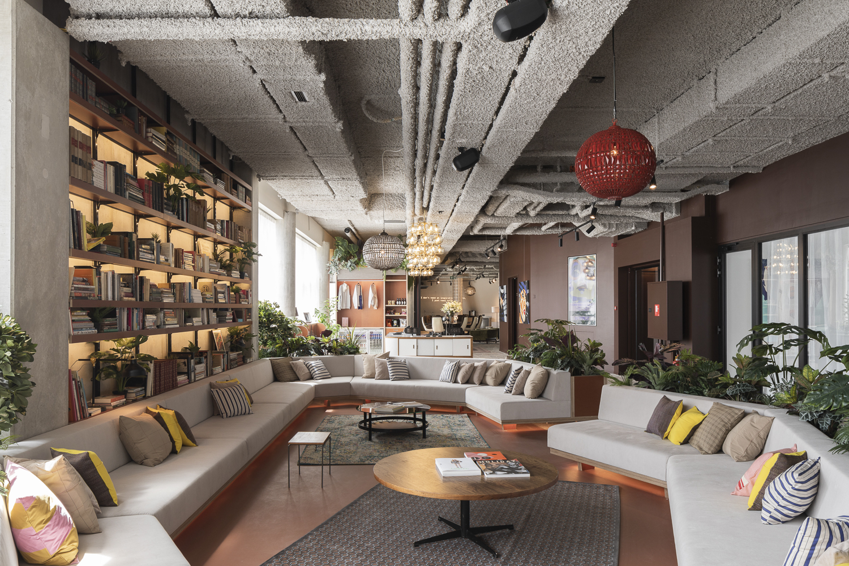
To ensure that students get the most out of the course and don't tire themselves out with unnecessary travel, we've set up an ideal package:
- Accommodation in a luxury 8-person « dormitory »
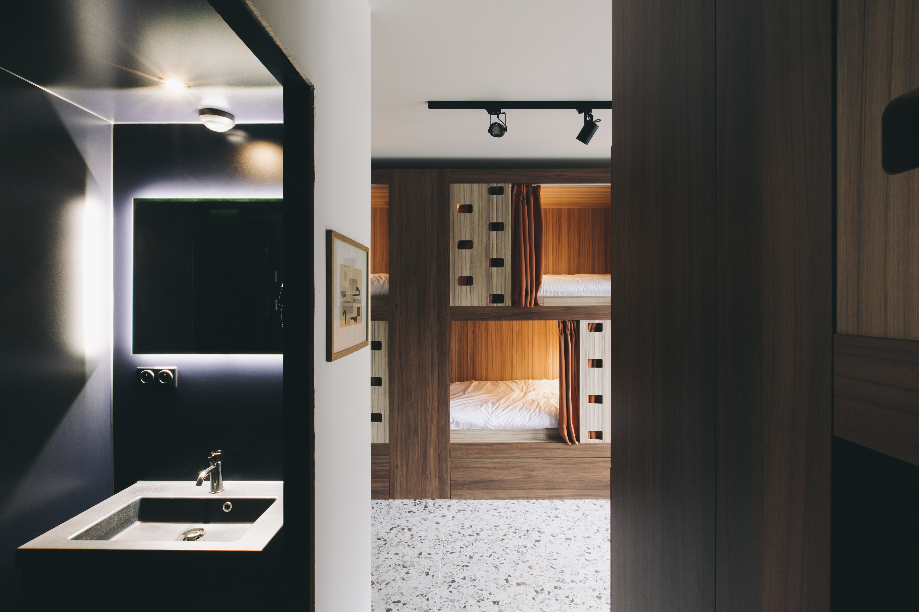

- Full board
- 24-hour supervisor
- Bus travel from the hotel to the studios, with at least one supervisor, except for the over-18s who may, on request, be free to traval on their own.
Hotel address: Esplanade Simone Veil 2, 4000 Liège (just in front of the Guillemins station)
Studios address: Place des Déportés, 4000 Liège
Travels will be made by bus and will take about 15 minutes.
To reserve your place, please fill in the form below. Please note that space is limited - first come, first served.
If you have any further questions, please contact us on infos@stagededanse.be
__________________________________

Accommodation Registration form Summer Intensive
I, the undersigned Mrs/Mr....................................................................., responsible for the child...................................................................... hereby register my daughter/my son for the accommodation package for the LIEGE SUMMER DANCE INTENSIVE from 4 to 11 August 2024. I declare to have subscribed an insurance covering the accidents which could occur during the stay, and consequently, releases Stage de Danse asbl of any responsibility in the event of accident, of loss or theft.
Boarder contact details:
Last name:…………………………………….
First name:……………………………………..
Complete address: …………………………………
Email address:…………..
Phone numbers: …………
For minors, name and phone number of the responsible person/emergency contact:
……………………………………………………………………………………………………

Selected package (tick the appropriate box) :
- From Sunday 4 to Sunday 11, so 7 nights for €590 including full board
- From Saturday 3 to Sunday 11, so 7 nights for €670 including full board
Meals:
- I have no food allergies
- I’m allergic to………………………………………..

Name and signature of a responsible person:

This form has to be sent by e-mail to infos@stagededanse.be
We will get back to you as soon as possible to confirm your booking and payment details.

We're looking forward to celebrating 20 years of Stage de Danse with you this summer!
The team.

