***Brussels Summer Dance Intensive***

***Boarding school from 5 to 11 July 2025 – Collector Residence***

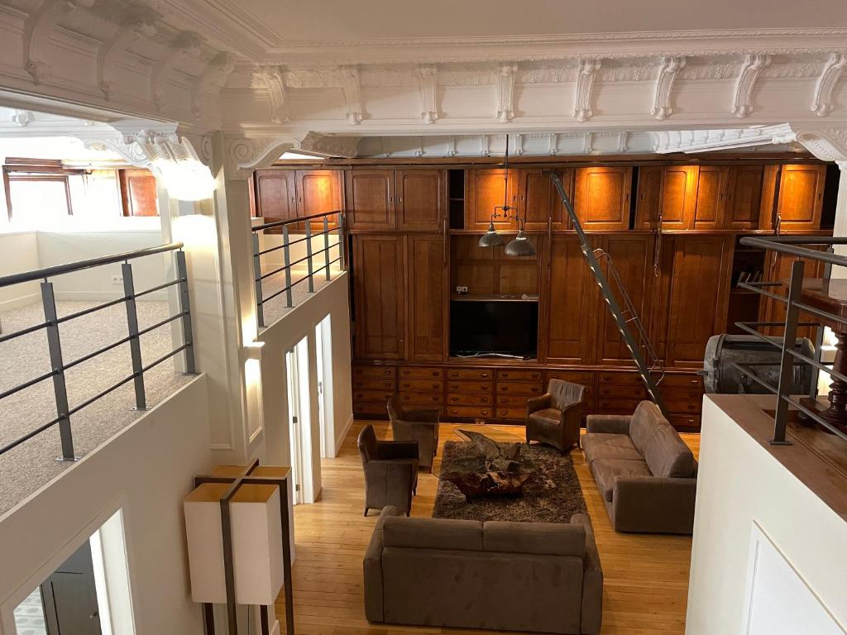

To ensure that students get the most out of the course and don't tire themselves out with unnecessary travel, we've set up an ideal package:

* **Accommodation in a large family residence**

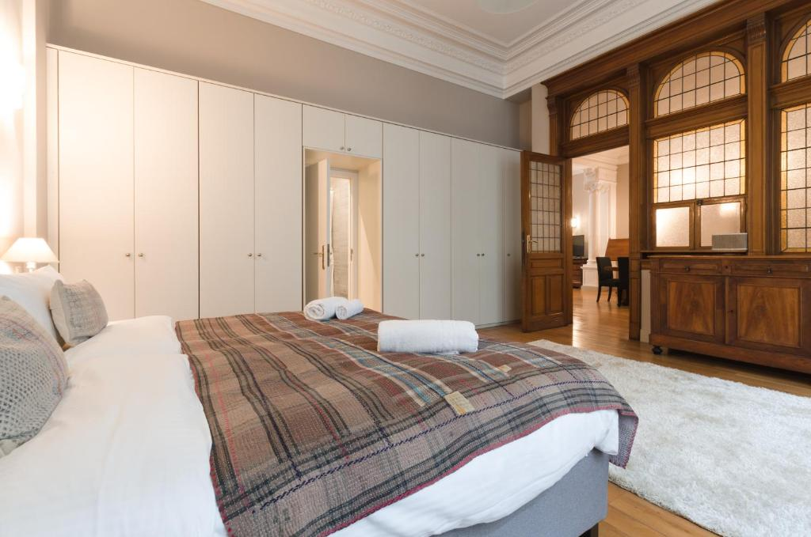

* **Full board available**
* **24-hour supervisor**
* **Travel** from the residence to the studios, with at least one supervisor, except for the over-18s who may, on request, be free to traval on their own.

**Residence’s address**: 47 Rue du Lombard, 1000 Bruxelles

**Summer Intensive’s address**: Cité des associations, Rue Émile Féron 153, 1060 Saint-Gilles

Travels will be made by bus and will take about 20 minutes.

To reserve your place, please fill in the form below. Please note that space is limited - first come, first served.

If you have any further questions, please contact us on [infos@stagededanse.be](mailto:infos@stagededanse.be)

__________________________________

***Accommodation Registration form Summer Intensive***

I, the undersigned Mrs/Mr....................................................................., responsible for the child...................................................................... hereby register my daughter/my son for the accommodation package for the BRUSSELS SUMMER DANCE INTENSIVE from 5 to 11 July 2025 (6 nights). I declare to have subscribed an insurance covering the accidents which could occur during the stay, and consequently, releases Stage de Danse asbl of any responsibility in the event of accident, of loss or theft.

**Boarder contact details:**

**Last name**:…………………………………….

**First name**:……………………………………..

**Birth date**:……………………………………..

**Age during the Intensive**:……………………………………..

**Complete address**: …………………………………

**Email address**:…………..

**Phone numbers**: …………

**For minors**, name and phone number of the responsible person/emergency contact:

……………………………………………………………………………………………………

**Selected package** (tick the appropriate boxes):

* Accommodation from Saturday 5 to Friday 11 July 2025, so 6 nights for €300
* Meals from Saturday 5 evening to Friday 11 midday for €300 including
* Travels with bus/tram for the whole week for €50
* I don’t need the travels package as I already have an active STIB pass for the Brussels zone

**Meals**:

* I have no food allergies
* I’m allergic to………………………………………..

Name and signature of a responsible person:

**This form has to be sent by e-mail to**  [**infos@stagededanse.be**](mailto:infos@stagededanse.be)

We will get back to you as soon as possible to confirm your booking and payment details.

**We're looking forward to sharing this Summer Intensive with you!**

**The Stage de Danse team**