Brussels Summer Dance Intensive
Boarding school from 5 to 10 July 2026 at
Meininger Hôtel Bruxelles City Center
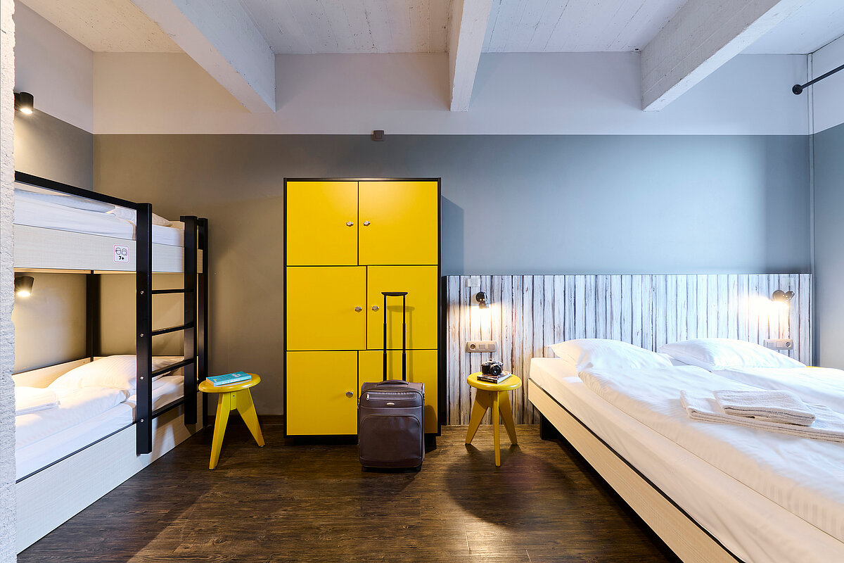
The package includes:
- Accommodation in family room for 3 or 4 people
- Full board
- 24-hour supervisor
- Supervision for travel to the studios (about 10-minute walk)
Hotel address: Quai du Hainaut 33, 1080 Bruxelles.
Studios address: Cité des Associations, Rue Émile Féron 153, 1060 Saint-Gilles
To book your spot, please fill in the form below. Please note that spots are limited - first come, first served.
If you have any further questions, please contact us on infos@stagededanse.be
__________________________________
Accommodation Registration form Brussels Summer Intensive
I, the undersigned Mrs/Mr....................................................................., responsible for the child...................................................................... hereby register my daughter/my son for the accommodation package for the BRUSSELS SUMMER DANCE INTENSIVE from 5 to 10 July 2026 at a cost of €650, including full board. I declare to have subscribed an insurance covering the accidents which could occur during the stay, and consequently, releases Stage de Danse asbl of any responsibility in the event of accident, of loss or theft.
Boarder contact details:
Last name:…………………………………….
First name:……………………………………..
Complete address: …………………………………
Email address:…………..
Phone number: …………
For minors, name and phone number of the responsible person/emergency contact:
……………………………………………………………………………………………………
Meals:
- I have no food allergies
- I’m allergic to………………………………………..
Name and signature of a responsible person :

This form must be sent by e-mail to infos@stagededanse.be
We will get back to you as soon as possible to confirm your booking and payment details.
We're looking forward to welcoming you in Brussels!
The Stage de Danse Team

