Liège Winter Dance Intensive
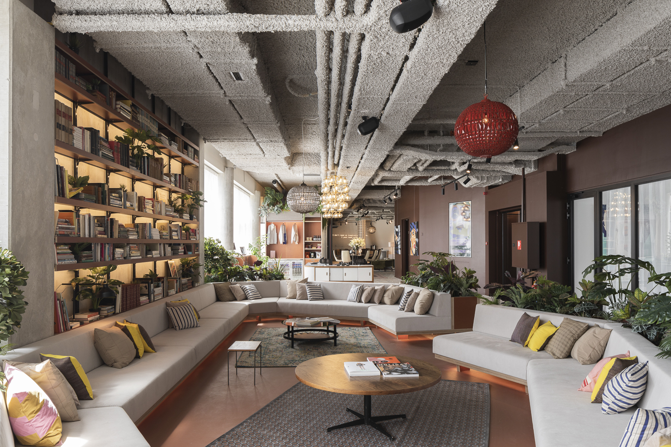
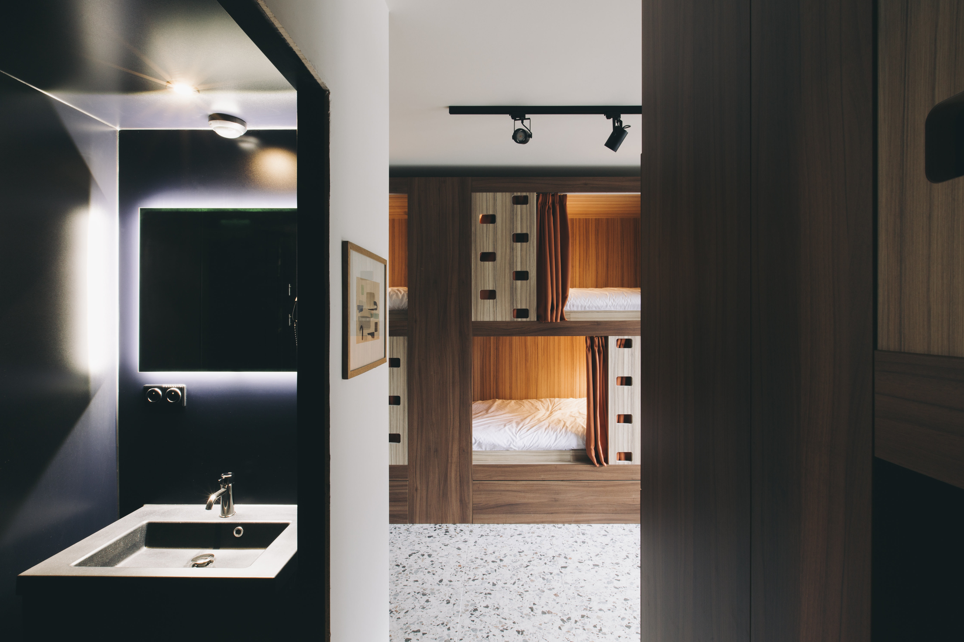
Boarding school from 20 to 23 December 2026 at Yust Liège Guillemins

To ensure that students get the most out of the course and don't tire themselves out with unnecessary travel, we've set up an ideal package:
- Accommodation in a luxury 8-person dormitory
- Full board
- 24-hour supervisor
- Bus travel from the hotel to the studios, with at least one supervisor, except for the over-18s who may, with a written parental authorization, be free to travel on their own.
Hotel address: Esplanade Simone Veil 2, 4000 Liège (just in front of the Guillemins station)
Studio address: Place Georges Ista 7, 4020 Liège
Travels will be made by bus and will take about 20 minutes.
To reserve your place, please fill in the form below. Please note that space is limited – first come, first served.
If you have any further questions, please contact us on infos@stagededanse.be
__________________________________

Accommodation Registration form Winter Intensive
I, the undersigned Mrs/Mr…………………………....................................................................., responsible for the child................................................................................................. hereby register my daughter/my son for the accommodation package for the LIEGE WINTER DANCE INTENSIVE from 20 to 23 December 2026. I declare to have subscribed an insurance covering the accidents which could occur during the stay, and consequently, releases Stage de Danse asbl of any responsibility in the event of accident, of loss or theft.
Boarder contact details:
Last name:…………………………………. First name:…………………………………..
Complete address: …………………………………
Email address:……………………………………….
Phone numbers: ………………………………………
For minors, name and phone number of the responsible person/emergency contact:
……………………………………………………………………………………………………
Selected package (tick the appropriate box):
- From Sunday 20 to Wednesday 23 December, so 3 nights for €330 including full board (no lunch on Sunday 20)
- I would like to arrive on Saturday December 19 and stay a night with the UNSUPERVISED accommodation (for under-18s, we will ask parents to sign an authorization form for this option), for a supplement of €70.
Meals:
- I have no food allergies
- I’m allergic to………………………………………..
Name and signature of a responsible person:

This form must be sent by e-mail to infos@stagededanse.be
We will get back to you as soon as possible to confirm your booking and give payment details.
We look forward to ending the year dancing with you!
Stage de Danse Team

